Safety values
now for diaphragm seals too

Klingenberg, April 2011.
WIKA is now able to offer safety values for their diaphragm seal systems too. Users can thus classify the reliability of individual components in the complete measuring assembly (diaphragm seal, connection, measuring instrument).

The new service is primarily aimed at customers with safety-critical requirements, for example in the chemical and petrochemical industries. WIKA has determined the values in collaboration with an external service provider. Using a Failure Modes, Effects and Diagnostic Analysis (FMEDA), the failure rates were calculated. These failure rates can be used by the operators for their own safety assessment in accordance with IEC 61508.

WIKA supplies diaphragm seals with various designs and special materials. This enables measuring instruments to be used even under the harshest conditions.

Number of characters: 882
Key words: Diaphragm seals, safety applications

Manufacturer:
WIKA Alexander Wiegand SE & Co. KG
Alexander-Wiegand-Straße 30
63911 Klingenberg/Germany
Tel. (+49) 9372 132-0
Fax (+49) 9372 132-406
E-mail sales@wika.de
www.wika.com

WIKA company photograph:
Diaphragm seal system for safety applications

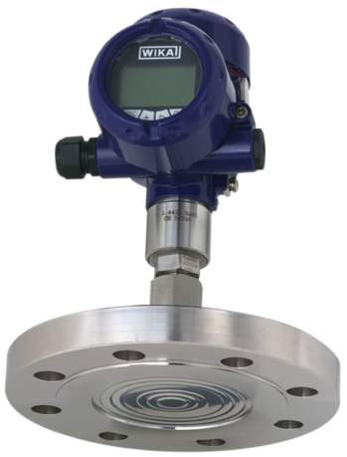

Edited by:
WIKA Alexander Wiegand SE & Co. KG
André Habel Nunes
Marketing Services
Alexander-Wiegand-Straße 30
63911 Klingenberg/Germany
Tel. (+49) 9372 132-806
Fax (+49) 9372 132-9803
E-mail a.habel-nunes@wika.de
www.wika.com

WIKA press release 07/2011

