Expansion thermometer with electrical output signal

Klingenberg, November 2011.
Under the badge of "intelliTHERM®", WIKA launches a new mechatronic product family, starting with the TGT70 thermometer. It combines, in a single instrument, an electrical output signal with on-site display - without the need for an external power supply.

The TGT70 is an expansion thermometer for general industrial applications. It operates in the range -40 … 250 °C, while the selectable output signals are 0.5 ... 4.5 V and 4 ... 20 mA.

With the new thermometer, temperature can be precisely controlled and adjusted, in the event of power loss the analogue display guarantees a correct measured value. Since only one measuring point is required, this product also saves costs.

Number of characters: 756
Key words: TGT70

Manufacturer:
WIKA Alexander Wiegand SE & Co. KG
Alexander-Wiegand-Straße 30
63911 Klingenberg/Germany
Tel. (+49) 9372 132-0
Fax (+49) 9372 132-406
E-mail sales@wika.de
www.wika.de

WIKA company photograph:
TGT70

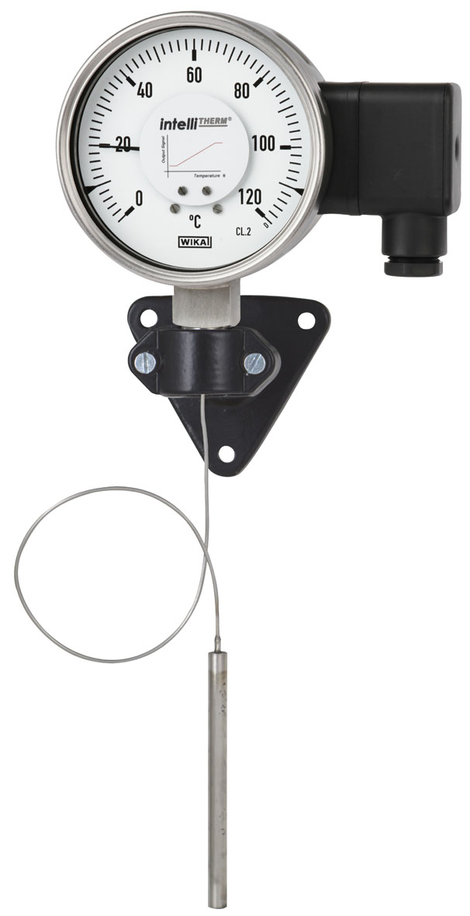

Edited by:
WIKA Alexander Wiegand SE & Co. KG
André Habel Nunes
Marketing Services
Alexander-Wiegand-Straße 30
63911 Klingenberg/Germany
Tel. (+49) 9372 132-8010
Fax (+49) 9372 132-8008010
E-mail a.habel-nunes@wika.de
www.wika.de

WIKA press release 15/2011

