Mobile SF₆ transfer unit features
strong flow rate

Klingenberg, March 2013.
With a portable SF₆ transfer unit, WIKA has now also opened up the gas-handling product segment. The model GTU-10 is particularly notable for its high performance and its intuitive operation.

The new SF₆ device handles a flow rate of 1.8 cubic metres per hour. This puts it right at the top of its class. The GTU-10's compressor runs oil-free, and thus the gas is kept safe from the possibility of contamination from lubricants.

The compact instrument is simple and safe to use. Its concept of operation precludes the emission of gas. In addition, the GTU-10 is a cost-effective product - its long maintenance intervals result in very low operating costs.

The GTU-10 completes WIKA's portfolio for SF₆ solutions. The product offering encompasses density monitors, valves, filling equipment and analysis instruments. In addition, the company offers practically-oriented product seminars and other training. WIKA has concentrated production and services in the area of SF₆ gas into a self-contained "Center of Excellence".

Number of characters: 1090
Key word: GTU-10

Manufacturer:
WIKA Alexander Wiegand SE & Co. KG
Alexander-Wiegand-Straße 30
63911 Klingenberg/Germany
Tel. +49 (0)9372 1320
Fax +49 (0)9372 132406
sf6-sales@wika.com
www.wika.de/sf6

WIKA company photograph:
SF₆ transfer unit model GTU-10

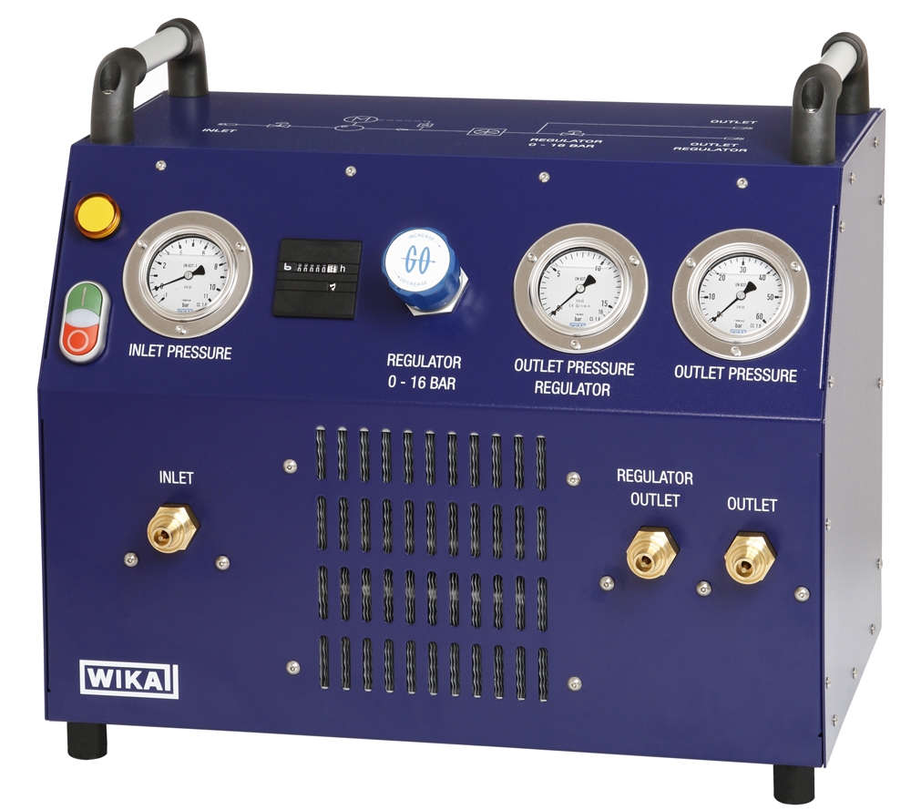

Edited by:
WIKA Alexander Wiegand SE & Co. KG
André Habel Nunes
Marketing Services
Alexander-Wiegand-Straße 30
63911 Klingenberg/Germany
Tel. +49 (0)9372 132-8010
Fax +49 (0)9372 132-8008010
andre.habel-nunes@wika.com
www.wika.com

WIKA press release 01/2013

