New WIKA website:
More info with fewer clicks

Klingenberg, June 2013.
Fresh design, efficient navigation and additional functionality: On WIKA's new website visitors can now get even more with fewer clicks.

The website is much tidier, visually clearer and with a wider range of services to offer. Customers can, for example, find the instrument they are looking for via a new product selector or directly via mega menus. Cross references will let them know about accessories, related products or applicable trade articles and WIKA blogs. By using a search form on the same level, the appropriate sales contacts, in the field or in the office, will be identified.

Furthermore, the newly designed Internet presence offers an expanded FAQ section and a detailed career area with an international appointments section. The website is linked with social media, including the WIKA channel on YouTube. On top of this, it is optimised for search engines and tablet PCs.

Number of characters: 959
Key words: New website

Manufacturer:
WIKA Alexander Wiegand SE & Co. KG
Alexander-Wiegand-Straße 30
63911 Klingenberg/Germany
Tel. +49 9372 132-0
Fax +49 9372 132-406
Vertrieb@wika.com
www.wika.com

WIKA company photograph:
New WIKA website

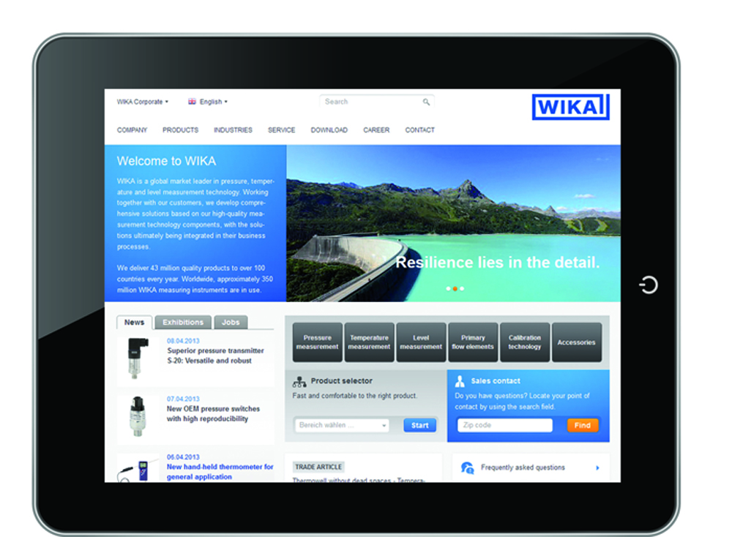

Edited by:
WIKA Alexander Wiegand SE & Co. KG
André Habel Nunes
Marketing Services
Alexander-Wiegand-Straße 30
63911 Klingenberg/Germany
Tel. +49 9372 132-8010
Fax +49 9372 132-8008010
andre.habel-nunes@wika.com
www.wika.com

WIKA press release 07/2013

