New pressure switch: More
operator convenience through adjustment knob

Klingenberg, September 2013.
WIKA has expanded its new series of OEM pressure switches by a model with increased operator convenience. Using an adjustment knob, the switch point for model PSM03 can be set continuously.

The new compact instrument enables the user to choose between two process connections - mounting thread or flange. In addition to the increased installation flexibility, the pressure switch has a long service life: Model PSM03 is designed for at least five million switching cycles.

Just like in the models PSM01 and 02, the core of the instrument is a flicker-free snap-action switch. It allows for high precision with a reproducibility of ±2 % of the full scale value in the measuring ranges 0.2 ... 2 bar to 40 ... 400 bar. WIKA delivers the three universally usable OEM pressure switches with a factory-set switch point on request.

Number of characters: 921
Key words: Pressure switch PSM03

Manufacturer:
WIKA Alexander Wiegand SE & Co. KG
Alexander-Wiegand-Straße 30
63911 Klingenberg/Germany
Tel. +49 9372 132-0
Fax: +49 9372 132-406
vertrieb@wika.com
www.wika.com

WIKA company photograph:
Pressure switch PSM03

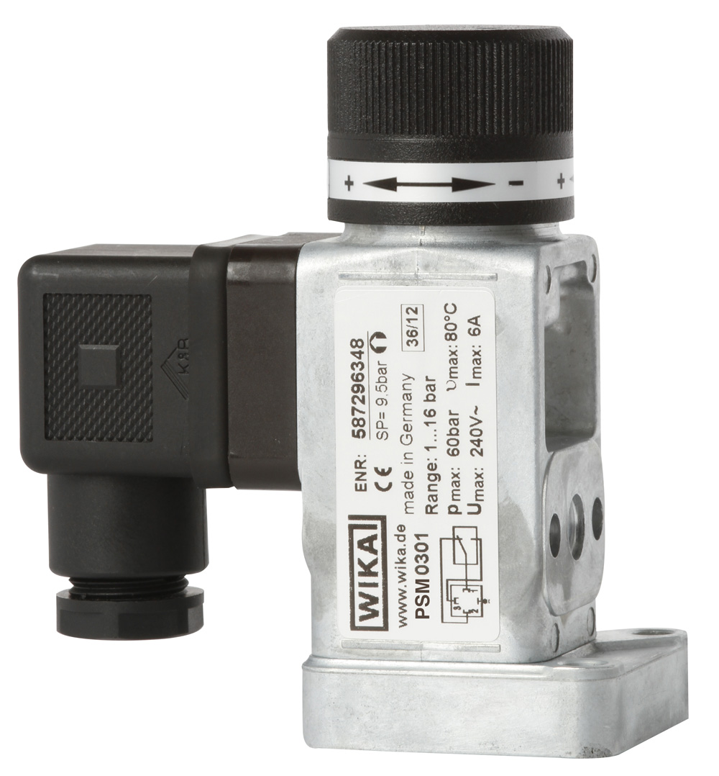

Edited by:
WIKA Alexander Wiegand SE & Co. KG
André Habel Nunes
Marketing Services
Alexander-Wiegand-Straße 30
63911 Klingenberg/Germany
Tel. +49 9372 132-8010
Fax: +49 9372 132-8008010
andre.habel-nunes@wika.com
www.wika.com

WIKA press release 10/2013

